 CHEMICAL ENGINEERING TRANSACTIONS  VOL. xxx, 2025 | A publication of  
The Italian Association
of Chemical Engineering
Online at www.cetjournal.it
Guest Editors: Bruno Fabiano, Valerio Cozzani
Copyright © 2025, AIDIC Servizi S.r.l.
ISBN 979-12-81206-xx-y; ISSN 2283-9216

Hydrogen and major industrial accidents - Hydrogen as a Sustainable Energy Solution: Balancing Potential with Safety Challenges
Atef Mahmoud, Vojtech Jankuj, Ales Bernatik*
Faculty of Safety Engineering, VSB-Technical University of Ostrava, 708 00 Ostrava, Czech Republic
ales.bernatik@vsb.cz
The urgent need for a shift to cleaner energy sources arose from global environmental concerns, particularly depletion of fossil fuels and their harmful effects on air quality and climate change. Being environmentally friendly, hydrogen is an appealing candidate for GHG-free energy generation and thus forms a key pillar of sustainable energy strategies. As governments, especially in the European Union, set far-reaching targets for climate neutrality, hydrogen is finding increasing applications in many sectors, ranging from industries to power generation and transportation. Hydrogen's versatility as energy carriers has opened a floodgate for research and development activities with the aim of improving its production, storage, and distribution processes. On the other side of the coin, hydrogen presents safety hazards related to its combustibility and volatility, thus requiring strict control and surveillance protocols to underpin advanced safety technology. The paper gives a comprehensive treatment of hydrogen's potential as a clean energy source and talks about its contribution to the global decarbonization agenda while analyzing safety incidents of the past with the lessons that can be highlighted. In addition, emphasis is placed on ensuring that strong safety measures—such as risk assessment, leak detection systems, and necessary regulations—are in effect to secure any dangers that hydrogen may pose. Through overcoming these hurdles, however, hydrogen can play an important role in achieving a sustainable and secure energy future.
  - Introduction
One of the major environmental challenges is the global dependence on fossil fuels which are environment unfriendly because nonrenewable energy sources are still in the leading position in the international energy scene. Currently, fossil fuels provide about 80.7% of the world’s energy (Halkos and Gkampoura 2020), making them heavily reliant on these resources Figure 1. But the continuous use of them involves great risks not only for their depletion but also for environmental pollution, especially in terms of GHG emissions and climate change. Both combustion of fossil fuels and industrial processes (i.e. extraction, refining, and transport) release carbon dioxide (CO₂), methane (CH₄), and other contaminants that worsen global warming and degrade air quality. In addition, this damage to habitat and long-term ecological damage caused by oil spills, coal mining and natural gas extraction. Although renewable energy sources like solar, wind and hydroelectric power are increasing, the use of them has not advanced sufficiently to combat the energy advantage of fossil fuels.

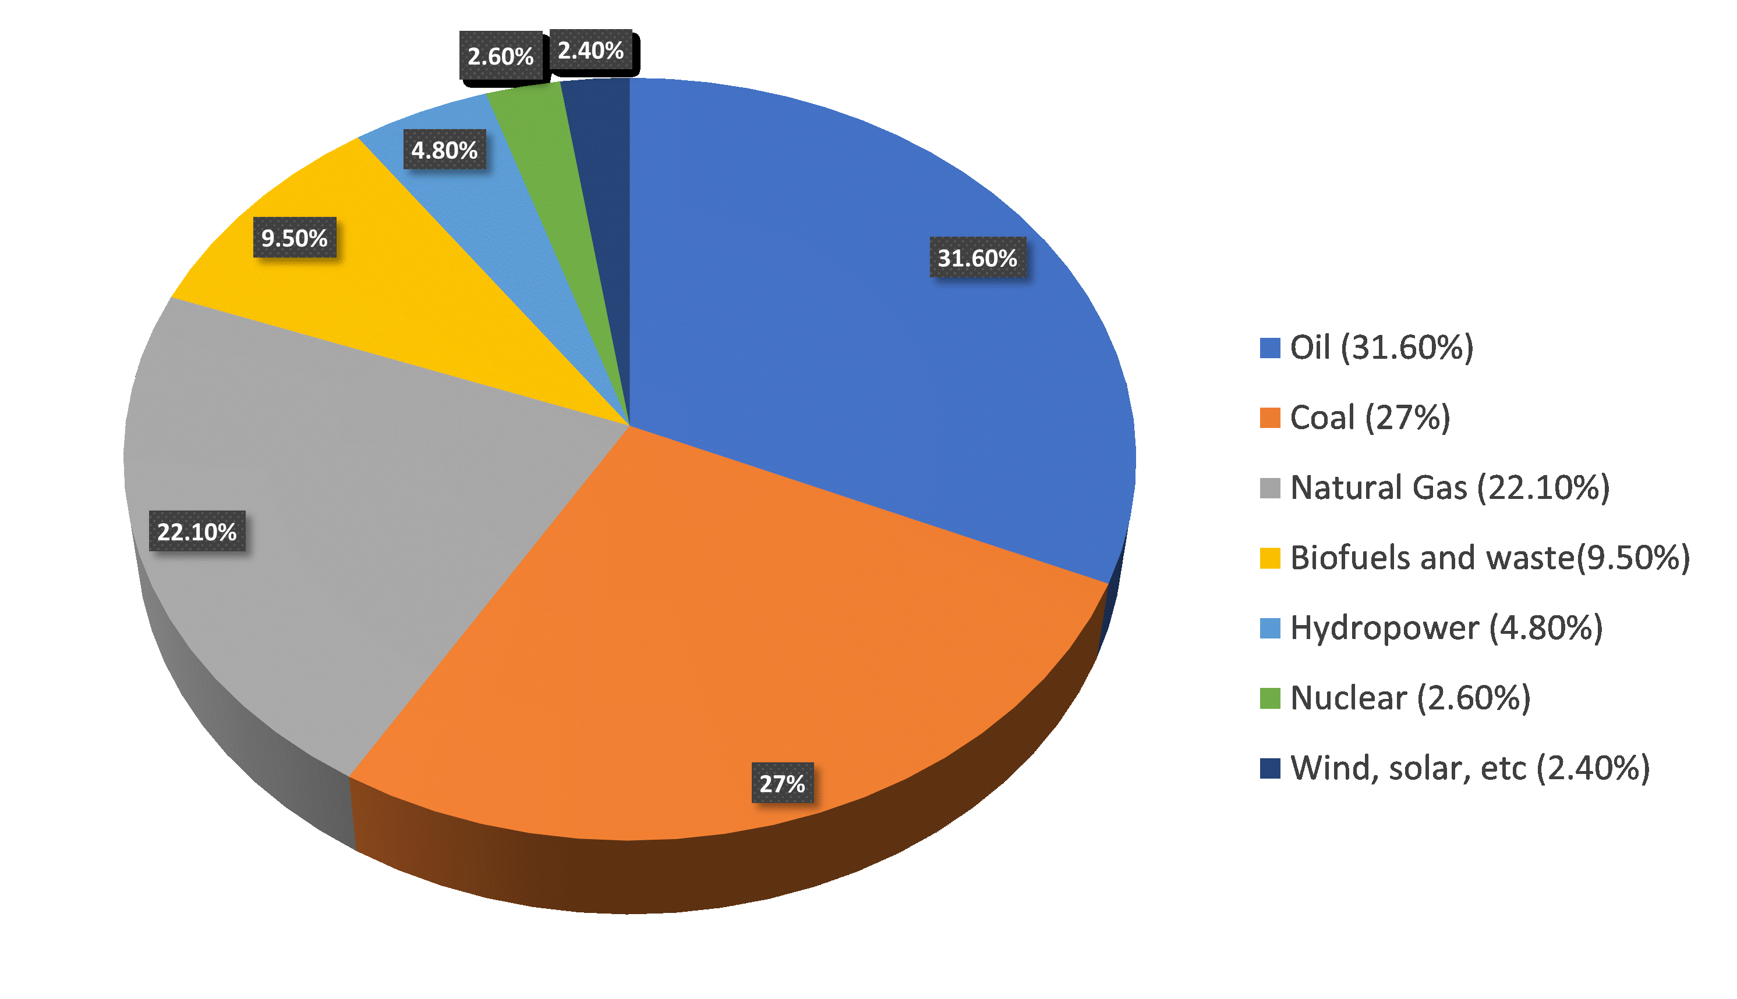

Figure 1: The world's energy sources in 2020 (Halkos and Gkampoura, 2020)

The burning of fossil fuels releases significant amounts of greenhouse gases (GHGs), which contribute to climate change and severe air pollution. According to the World Health Organization (WHO), air pollution contributed to an estimated 4.2 million premature deaths globally in 2019, highlighting its impact on public health (WHO, 2022). In response to these environmental and health challenges, many regions have introduced stringent policies aimed at reducing emissions, including the European Union's (EU), are taking concrete steps toward reducing greenhouse gas emissions. The European Climate Law outlines a commitment to achieving climate neutrality by 2050. To meet this long-term goal, EU member states are required to reduce their net emissions by at least 55% by 2030 compared to 1990 levels. (European commission, 2021).
Achieving these ambitious targets will require the adoption of cleaner, sustainable energy alternatives, with hydrogen emerging as a key player in this energy transition.
Hydrogen is increasingly being promoted as a cleaner alternative to fossil fuels. Hydrogen, when used as an energy source, does not produce direct GHG emissions, presenting itself as a crucial component of the clean energy transition. However, while hydrogen is considered environmentally friendly, its use introduces significant safety risks, especially in industrial settings. This paper explores the advantages of hydrogen as an alternative energy source, while emphasizing the importance of stringent safety measures to prevent hydrogen-related accidents in industries.
  - Hydrogen as a Clean Energy Alternative
Hydrogen offers significant potential as a cleaner energy source, primarily because it can produce energy without emitting GHG when combusted, it produces only water vapor as a byproduct, which significantly reduces harmful emissions. Furthermore, hydrogen can be produced through electrolysis using renewable energy sources, making it a carbon-neutral solution for energy production.
Several countries and industries are increasingly investing in hydrogen technologies as part of their long-term energy strategies. Hydrogen's role is particularly important in the context of smart cities and heavy industries, where clean energy technologies are being integrated into various applications, from mobility and transportation to heating and cooling systems. (IRENA, 2019). The flexibility of hydrogen also allows it to be used as an energy storage medium, addressing the intermittency issues of renewable energy sources like solar and wind power.
Its versatility allows for integration into various sectors, including industrial applications, transportation, and heating systems, making it a vital component of the transition to a low-carbon economy. Hydrogen-powered technologies, such as fuel cells, can support energy storage and electrification efforts, particularly in urban regions aiming to become "smart cities”.
By replacing fossil fuels in heavy industries and the mobility sector, hydrogen could substantially reduce the environmental footprint of these sectors. Furthermore, its use in decentralized energy systems allows for the storage of surplus renewable energy, mitigating the intermittency challenges associated with solar and wind power.
  - Safety Concerns and Incident Analysis
Despite the clear environmental benefits of hydrogen and its numerous benefits, hydrogen is not without risks, it presents significant challenges in terms of safety. Hydrogen is a highly flammable and reactive gas, with a wide range of flammability in the air (between 4% and 75% by volume), making it more prone to explosions than other fuels (Ekins, 2010). Its low ignition energy and ability to leak through small openings further exacerbate these risks, as even small leaks can create explosive mixtures when leaked and exposed to air. In the presence of ignition sources, these mixtures have the potential to cause fires or explosions. Due to these risks, adopting hydrogen on a large scale requires strict safety measures (NREL, 2020).
The Hydrogen Incident and Accident Database (HIAD 2.1) which published from Joint Research Center (JRC) which is the European Commission's science and knowledge service has documented 755 hydrogen-related incidents as of 2023, which tracks hydrogen-related incidents, reports that 755 hydrogen-related accidents have occurred up until 2023 (HIAD, 2023). These incidents underscore the importance of establishing and implementing a clear safety system including safety protocols to minimize risks. The unique properties of hydrogen, such as its low molecular weight and tendency to escape from leaks, necessitate specialized detection and containment systems to prevent dangerous situations. Hydrogen-related incidents have been notable in history, including the Hindenburg disaster in May 1937. This involved a zeppelin filled with approximately 200,000 cubic meters of hydrogen igniting in under a minute, resulting in the tragic loss of 35 lives out of 97 passengers onboard. More recently, in September 2023, an incident occurred as result of releasing the pressurized hydrogen gas while recommissioning equipment following planned preventive maintenance (PPM) at a chemical plant in Northwest Queensland, Australia. This event led to an explosion and subsequent fire, injuring three workers and causing extensive damage to the facility. (Resources Safety & Health Queensland, 2023)

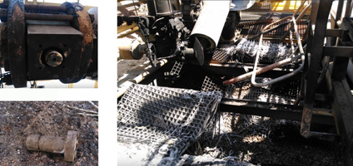

Figure 2: The aftermath of the explosion at chemical plant in Northwest Queensland, Australia (Resources Safety & Health Queensland, 2023)

According to the Hydrogen Accident and Incident Database (HAID), the primary causes of hydrogen-related incidents are attributed to management and organizational factors (46%), individual factors (30%), and job-related factors (24%). These underlying causes are further categorized as stemming from material or manufacturing errors (42%), system design flaws (30%), and installation errors (12%).

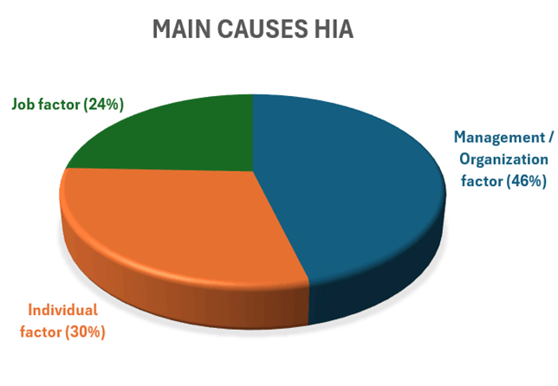
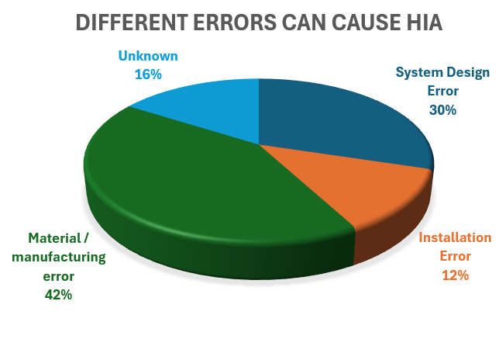

Figure 3: Main causes and contributing errors in Hydrogen incidents and accidents (HIAD, 2023)
  - Establishing Safe Systems of Work and Risk Management
To ensure that hydrogen can be used safely and effectively, it is essential to establish comprehensive risk management strategies. This includes creating a Safe System of Work (SSW) to mitigating the risks associated with hydrogen use in industrial applications.
A SSW means safe person, safe equipment and safe place. This involves establishing comprehensive suitable and sufficient risk assessments, hazard identification, and control measures designed to minimize the potential for accidents. As part of this system, industries must ensure the presence of effective gas detection systems, the use of explosion-proof equipment, and adherence to strict operational procedures.
Risk assessments must be regularly reviewed and updated to address evolving technologies and operational conditions and should include an analysis of possible hydrogen leakage scenarios which related to all aspects of hydrogen handling, from transportation and storage to application in various industrial processes, ignition sources, and potential human error. Additionally, the implementation of control measures, such as regular maintenance checks, adequate ventilation, and worker training, is essential in preventing the occurrence of accidents (Quintiere, 2017). Emergency response protocols must also be in place, ensuring that in the event of an accident, the response is quick, coordinated, and effective.
Understanding and learning from previous hydrogen-related accidents is vital in preventing similar incidents in the future. The lessons learned from past incidents provide valuable insights into improving safety protocols. For instance, the Hindenburg disaster of 1937, while often cited as a hydrogen-related failure, was due in part to the flammable materials used in the airship’s construction (HIAD, 2023). More modern incidents, such as the 2004 accident at the Praxair plant in St. Louis, Missouri, involved hydrogen leaks that led to explosions and fires (CSP, 2005). These incidents highlight the importance of stringent leak detection systems and adherence to safety protocols.
In addition to analyzing incidents, the sharing of safety data through platforms like the HIAD 2.1 database enables industries to better understand the causes of hydrogen-related accidents and implement preventive measures. This approach fosters a culture of continual improvement in hydrogen safety practices.
  - Future Prospects: Hydrogen Adoption with Safety Integration
As hydrogen continues to play a central role in the clean energy transition, ensuring its safe adoption becomes even more critical. Advanced technological solutions, including improved storage materials and monitoring systems, will further mitigate the risks associated with hydrogen use. Additionally, developing fire-resistant infrastructure and implementing advanced detection systems can enhance the safety of hydrogen-powered facilities.
Educating the workforce involved in hydrogen production, transportation, and usage is equally important. Proper training will enable personnel to handle hydrogen safely and respond effectively in the event of an emergency. Continued research into hydrogen behavior, coupled with cross-industry collaboration, will contribute to safer hydrogen usage on a global scale.
  - Conclusion
Hydrogen represents a promising alternative to fossil fuels in the transition towards a cleaner and more sustainable energy future. Its environmental benefits are clear, particularly in terms of reducing GHG emissions and improving air quality. However, hydrogen's highly flammable nature and reactivity present significant risks, especially in industrial settings. Establishing a comprehensive Safe System of Work (SSW) that includes risk assessments, effective control measures, and well-trained personnel is essential for minimizing these risks.
Learning from past accidents and sharing data through centralized platforms will play a key role in improving hydrogen safety practices. As hydrogen becomes an increasingly important part of global energy systems, its safe integration into industries will be paramount to achieving both environmental and safety objectives.

References
References:
[1] SG.E. Halkos, E.C. Gkampoura, 2020, Reviewing usage, potentials, and limitations of renewable energy sources Energies. Department of Economics, University of Thessaly, 38333 Volos, Greece
[2] World Health Organization – WHO, 2022, Ambient (outdoor) air pollution, Geneva, Switzerland.
[3] European Union, 2021, European climate law, European Commission, 1049 Bruxelles/Brussel, Belgium.
[4] International Renewable Energy Agency – IRENA, 2019 New IRENA Report Explores Potential of Green Hydrogen, Masdar City, Abu Dhabi.
[5] Paul Ekins, 2010, Hydrogen Energy: Economic and Social Challenges, Earthscan, London, UK.
[6] National Renewable Energy Laboratory – NREL, 2020. Hydrogen Safety, Golden, Colorado, USA.
[7] European Union, 2023, Hydrogen Incident and Accident Database - HIAD, European Commission, 1049 Bruxelles/Brussel, Belgium.
[8] Resources Safety & Health Queensland (RSHQ), 2023, Hydrogen explosion and fire during the recommissioning of plant equipment post maintenance, Brisbane Qld 4001, Australia.
[9] Quintiere, J. G., 2017, Principles of Fire Behavior and Combustion. CRC Press, Headquarters Boca Raton, Florida, USA
[10] U.S. Chemical Safety Board – CSB. (2005). Investigation Report: Hydrogen Fire at Praxair St. Louis., Pennsylvania Ave N.W., Washington, D.C., USA.

